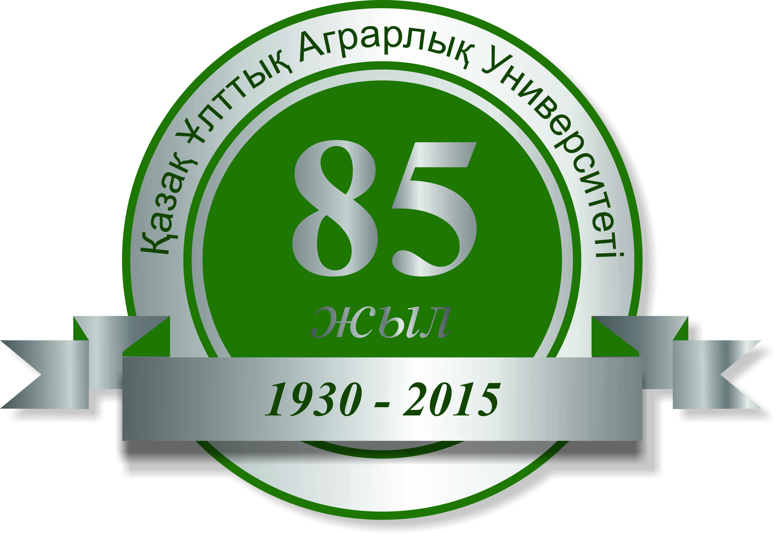

INTERNATIONAL SCIENTIFIC-PRACTICAL CONFERENCE
“THE NEW STRATEGY OF SCIENTIFIC AND EDUCATIONAL PRIORITIES IN THE СONTEXT OF AGRARIAN- INDUSTRIAL DEVELOPMENT ” DEDICATED TO THE 85th ANNIVERSARY OF KAZAKH NATIONAL AGRARIAN UNIVERSITY

Kazakh National Agrarian University, оne of the oldest universities in Kazakhstan, training specialists for the agrarian sector of economy, this year is celebrating its 85th anniversary.
The International scientific and practical conference “The New Strategy of Scientific and Educational Priorities in the Context of Agrarian- Industrial Development ” will be held at Kazakh National Agrarian University in November 27-29, 2015 in honor of the anniversary celebration.
The aim of the conference: promotion of accelerated innovative development, enhancement of agrarian science and education competitiveness in Kazakhstani agricultural sector.
Organizers: Ministry of Agriculture of the Republic of Kazakhstan, non-profit joint stock company "National Agrarian Research and Educational Center", Kazakh National Agrarian University.
Practical issues of agro-industrial complex modernization on the basis of innovation, integration of agrarian science, education and production in Kazakhstan will be discussed during the international scientific and practical conference.

Conference themes:
Session 1. Agrarian innovations and ecology
Session 2. Forestry innovation and environment protection
Session 3. Water issues and land reclamation
Session 4. Consulting and agribusiness
Session 5. Agrarian engineering and professional education
Session 6. Technologies of bio-resources
Session 7. Veterinary safety

The conference will be attended by the members of the Global Consortium of Agrarian Universities, rectors of leading foreign and Kazakhstani higher education institutions, directors and employees of scientific research institutes, experimental farms and agricultural entrepreneurs.
Papers will be published before the conference. The publication is free.

Requirements for articles publication:
Size of publications is 3-5 pages. Papers are accepted in Kazakh, Russian or English languages. Typing in the editor of Word (format doc, RTF), fonts - Times New Roman, size 14, with single line spacing, indent - 1.0 cm, margins: top, bottom, left, right - 2.0 cm. In the upper left corner of the article- UDC is indicated, lower - the name of the article in capital and bold letters, aligned to the center. Under the title at an interval in the middle - authors' names and initials of are indicated. Lower, in the center - the full name of the organization, city, country, e-mail address. The article text begins with a red line through the interval after the name of the institution.
Figures and graphics should be clear, in black and white (Editor Excel). The list of references is put after the main text.
At the beginning of the article a brief abstract in English is given. The file of submitted work should be called by the name of the first author.

The scheme of an article

UDC
Empty line
ARTICLE TITLE
Empty line
Ivanov I.I.
Full name of organization, city, country
Empty line
Summary in English
Empty line
Keywords:
Empty line
Main text
List of references

Doctoral and graduate students should specify the details of their research advisor (if he/she is not recorded as a co-author) in their papers.

The deadline for submitting articles for publication is November 10, 2015.

For inquiries contact the Department of Science (KazNAU main building, office №105, Abay ave. 8, Almaty, phone.: +7 727 262-89-82, 267-65-37, e-mail: zhumagul77@yandex.ru

